Dr. Wendy Kline Univ. Hall 325
wkline@purdue.edu OH: T,R 1:30-2:30

History 35205:
death, disease, and medicine in 20th-century american history

Fall 2017
University hall room 217
TR 3:00-4:15

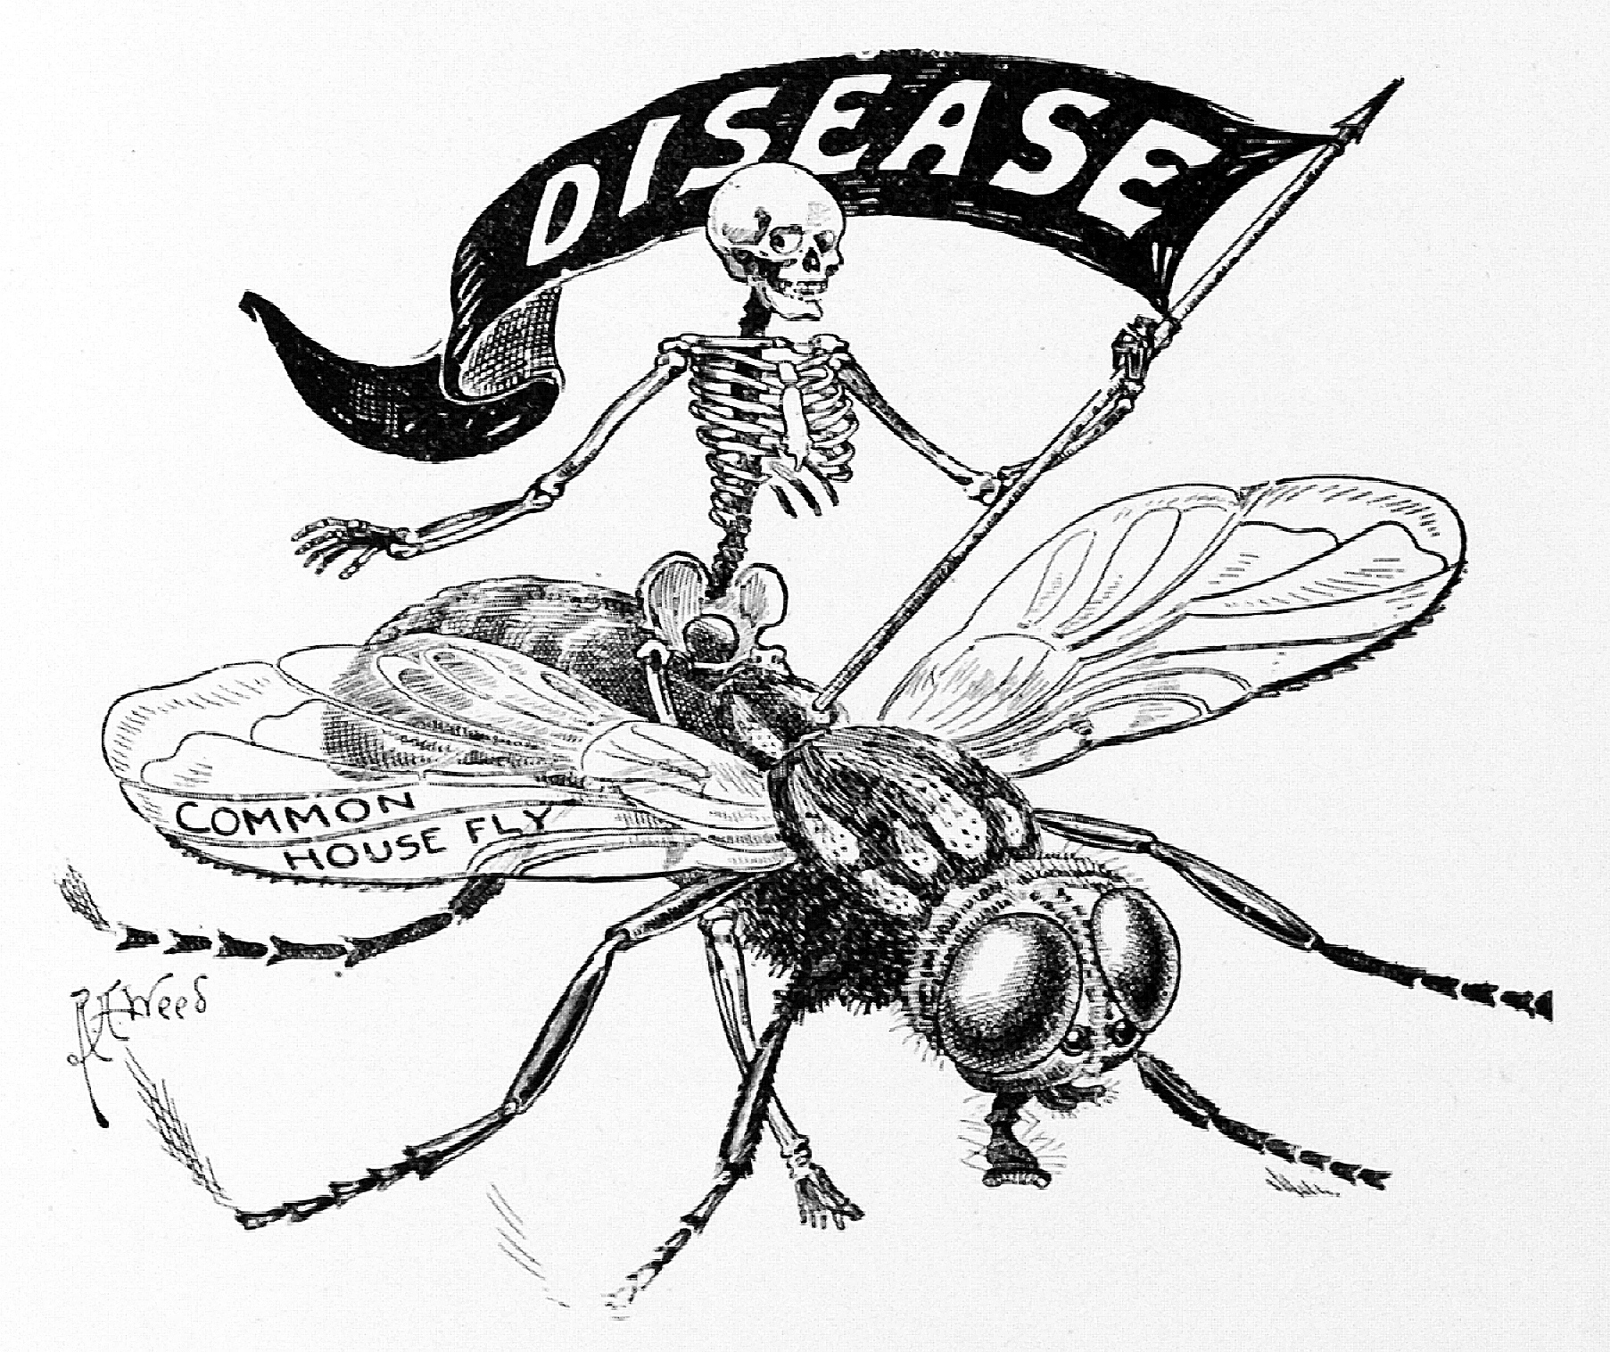

Course Description: Outbreaks of Ebola and Zika remind us that despite medical technology and scientific advance, disease continues to shape our identities and interactions with others. In this course, we will investigate the role of disease and medicine on twentieth-century American culture and society. From polio to AIDS, ideas about risk, contagion, health, and death have been intricately linked to politics, race, gender, class, and ethnicity.
*This course meets requirements for Purdue's Medical Humanities Certificate. Students interested in the Medical Humanities certificate should review the website, contact the Medical Humanities program, or contact their academic advisor for more information.

Course Objectives:
This course encourages students to recognize, most fundamentally, that disease has a history, and that its history is embedded in culture. We will analyze the ways in which societal assumptions about health and sickness help to determine the course of an epidemic. We will examine the role of doctors, public health workers, politicians, and patients in public health crises. By the end of the semester, students should be able to relate particular diseases and epidemics with larger trends in history in order to understand the relationship between health and history.

required books (Available at the bookstore or at amazon.com):

- Biss, Eula, On Immunity: An Inoculation
- Kalanithi, Paul, When Breath Becomes Air
- Kolata, Gina, Flu: The Story of the Great Influenza Panic of 1918 and the Search for the Virus that Caused it
- Markel, Howard, When Germs Travel
- Oshinsky, David, Polio: An American Story

This course does not require any prerequisites.

Course Requirements and Grading

REQUIREMENTS DATE % of final grade
JOURNAL ENTRIES  (PICK TWO)*  *no credit for late entries | 9/5, 10/3, 11/9, 11/28, 12/7 | 30 (15 points each)
FINAL TAKE-HOME EXAM | 12/14 by 5 p.m. | 30
ATTENDANCE/ PARTICIPATION | (includes 5 quizzes) | 40

94-100% = A  91-93 = A-  88-90 = B+  83-87 = B  81-83 = B-  78-80 = C+ | 73-77 = C  71-73 = C-  68-70 = D+  63-67 = D  60-62 = D-  < 60% = F

Attendance Policy:
Attendance is mandatory. Arrive on time. I will take attendance at the beginning of class, and, along with participation and quizzes, it counts for 40% of your grade. If there is an occasion where you must leave early, notify me before class starts and sit near an exit. Be courteous. Do not disrupt the professor or your fellow students.

Important Notes:

* Cheating / Plagiarism: Plagiarism refers to the reproduction of another's words or ideas without proper attribution. Cheating, plagiarism, and other forms of academic dishonesty are serious offenses, and will result in a failing grade and notification of the Dean of Students Office. Don't do it.
*Course evaluations: During the 15th week of classes, you will receive an official email from evaluation administrators with a link to the evaluation site. You will have two weeks to complete the evaluation. I do not see your evaluation until after grades are submitted.
*Email etiquette: Outside of class or office hours, communicate with your professor by email. State the reason for your email in the subject line (ex: “question about essay”). Include a full salutation (ex: “Dear Professor”), and closing with your full name (ex: “Sincerely, Robert Owen”). Please use full sentences, correct grammar, and punctuation.

*Electronic Devices in the Classroom: Personal laptops or tablets are not allowed in class unless you have purchased the reading as an ebook and need to refer to the reading during class discussion. Please inform me if you have special circumstances. I should not see or hear any other electronic devices once class has begun. Please turn them off or put them in silent mode and keep them in your bag, jacket, etc. No audio or video recording is allowed in class without prior permission.
*Regulations regarding Personal Information
If students wish to allow the instructor to disclose information such as grades in letters of recommendation, they must provide written consent according to FERPA. Also because of FERPA, faculty cannot email grades to students.
*Emergency Announcements
In the event of a campus emergency or school closure, classes or assignments may be cancelled. Remember to check your school email, connected through Blackboard, in a timely manner for any updates.

Schedule and Readings
Please note: Reading assignment in parentheses should be completed before designated class. Come to class prepared to answer questions in response to that day’s reading assignment.

Part I: contemporary issues: the vaccine controversy

T Aug 22 What is the history of medicine and why does it matter?
R Aug 24 Calling the Shots (read On Immunity pp 1-39)

T Aug 29 Wakefield (read On Immunity pp. 40-82 )
R Aug 31 public health vs. individual health (read On Immunity 83-124 )

T Sept 5 discussion of Biss (finish On Immunity)
*reading quiz 1/ journal entry option 1due by 9 a.m. on Bb

Part II: GERMS! immigration, ethnicity, and disease

R Sept 7 Tuberculosis (read When Germs Travel Intro and ch. 1)

T Sept 12 Bubonic Plague in Chinatown (read When Germs Travel ch. 2)
R Sept 14 Eugenics and Immigration Restriction (no reading)

T Sept 19 Medical Inspections (read When Germs Travel ch. 3)
R Sept 21 Ellis Island (no reading)

T Sept 26 Lice, Typhus, and Riots (read When Germs Travel ch. 4)
R Sept 28 Typhoid Mary (no reading)

T Oct 3 Haitian Immigrants and AIDS (read When Germs Travel ch. 5)
*reading quiz 2/ journal entry option 2 due by 9 a.m. on Bb

R Oct 5 NO CLASS (read When Germs Travel ch. 6 on cholera alarm)

T Oct 10 NO CLASS: FALL BREAK

Part III: polio

R Oct 12 FDR and disability (read Polio Intro, chs 1&2)

T Oct 17 March of Dimes (read Polio chs. 3&4)
R Oct 19 Mothers March (read Polio ch.5)

T Oct 24 Salk (read Polio chs. 6&7)
R Oct 26 The Ethics of Human Experimentation (read Polio chs. 8&9)

T Oct 31 Plague Season (read Polio chs. 10&11)
R Nov 2 The Cutter Fiasco (read Polio chs. 12&13)

T Nov 7 Sabin Sundays (read Polio chs. 14&15)
R Nov 9 Celebrities (read Polio chs. 16&Epilogue)
*reading quiz 3/ journal entry option 3 due by 9 a.m. on Bb

Part iv: flu

T Nov 14 1918 (read Flu, Prologue, chs. 1&2)
R Nov 16 From Sailors to Swine (read Flu, chs. 3&4)

T Nov 21 Swine Flu (read Flu, chs. 5&6)
R Nov 23 NO CLASS (thanksgiving) (read Flu, chs. 7&8)

T Nov 28 Mysteries and Hypotheses (read Flu, chs. 9&10)
*reading quiz 4/ journal entry option 4 due by 9 a.m. on Bb

Part V: Death and dying

R Nov 30 Being Mortal (read When Breath Becomes Air, Foreword, Prologue)

T Dec 5 Difficult decisions (read When Breath Becomes Air, Part I)
R Dec 7 Ethics (read When Breath Becomes Air, Part II, Epilogue)
*reading quiz 5/ journal entry option 5 due by 9 a.m. on Bb

Final paper due Dec 14 by 5 p.m.: via Blackboard safeassign

DETAILED EXPLANATION OF ASSIGNMENTS

EXPLANATION OF INTELLECTUAL JOURNAL
Each person in the course will be expected to write two journal entries on blackboard. The purpose of this journal is to encourage students to reflect on the readings and material covered in the course and thereby, to help students prepare for in-class discussions. On a larger scale, the journal will help you and me track the development of your intellectual understanding and questioning throughout the course.
You are required to write a total of TWO journal entries. There are FIVE possible dates for entries to come in: 9/5, 10/3, 11/9, 11/28, 12/7. Here’s the catch: I won’t accept any late entries. They are due by 9 a.m. on those dates via blackboard.
-Please write a total of 400-500 words per entry. That’s about two typed double-spaced pages. Write in full sentences and in clearly organized paragraphs. Demonstrate that you’ve engaged in some way with the reading material. Feel free to link the reading with discussions we’ve had in class or with previous readings, but be sure to focus primarily on the actual assigned chapters. How is this author approaching his or her subject matter? What kinds of issues are raised by this particular subject? What sources is the author using, and what argument is he or she making? (i.e. why does the subject matter? Why should we care about it?)

- FINAL TAKE-HOME EXAM:
- DUE DATE: Dec 14 by 5 p.m. via Blackboard SafeAssign
- FORMAT: essay questions; 20% of course grade. You will get specific essay questions approximately one week before the exam.

HOW WRITTEN WORK WILL BE EVALUATED:
I am less interested in a regurgitation of facts than a thoughtful analysis of the question, based on evidence from readings, lectures, discussions, and films.
Planning and organization- Before you jump into answering the question, make sure that you have prepared an outline of your essay. Each paragraph that you then write should correspond to a specific point that you have in your outline.
Introduction and thesis- Each question requires that you come up with an argument—or thesis—that directly answers the question. This thesis statement should be in your introductory paragraph. The rest of the introduction should state the meaning and significance of the issue as it will be discussed in the body of the essay (you don’t need to spend time repeating or paraphrasing the question, or describing the specific scheme of organization that your essay will take).
Body-The body of your paper should provide examples and evidence to support your thesis. You may express an opinion, but your opinion should be based on the materials and evidence.
Conclusion-Use your final paragraph not only to summarize your main points, but to demonstrate the significance of your findings.
Proofreading-save a few minutes before the end of class time on the midterm for rereading your essay in order to confirm that your have conveyed what you intended.

